Job Placement Research

Go to this website:
https://www.awinfosys.com/das/sd44/student/activityfinder.asp

Click on the type of job you would like and see the different actual placements under each category. Choose 5 placements that you would like.
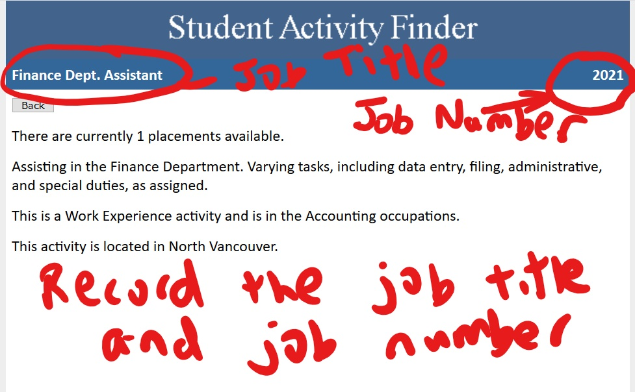
Write down 5 jobs that you want. I need the job title and job number. Rank your jobs from 1 to 5.

